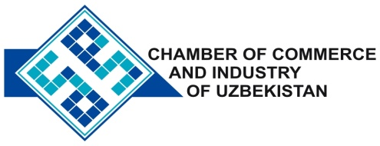

**Commercial offer of Uzbek Products to Foreign Buyer**

Dear Sirs, №AP-005

We offer quotation of Uzbek company Ltd «SDK GROUP AND».

**Information about the company:**

Company «SDKGROUPAND» was founded in 2009. «SDKGROUPAND» - is one of the first companies producing oil, air and fuel filters for all brands of cars and agricultural equipment in the region of Central Asia.

**List of products:**

Oil filter

Panel air filter

Air filter

Fuel filter

**Benefits:**

Enterprise is organized in accordance with international standards and found to be effective.

**Terms of delivery:** FCA Tashkent

If you are interested, we are happy to provide additional information in accordance with your request.

E-mail: [export@chamber.uz](mailto:export@chamber.uz)

Website: [www.chamber.uz](http://www.chamber.uz)

Export Promotion Department.

Chamber of Commerce of the Republic of Uzbekistan.